In Chapter 1, page 17, there is an Entity Relationship (ER or EER) diagram for the AP (Accounts Payable) database. Take a look at the diagram and determine what foreign key for the tables in 1 and 2 below relate to a primary key in another table for all tables. As an example, the terms table has a primary key (term s_id) that relates it to the foreign key (default_terms_id) in the vendors table. Thus the foreign key default_terms_id relates the vendors table to the primary key term s_id in the terms table.  
  
**Based on the above, answer these two questions:**

1. How is the **general_ledger_accounts** table related to the **vendors** table? You must name the column that relates.
   1. The foreign key *default_account_number* in the **vendors** table relates the **vendors** table to the primary key *account_number* in the **general_ledger_accounts** table.
2. How is the **terms** table related to the **invoices** table? You must name the column that relates.
   1. The foreign key *terms_id* in the **invoices** table relates the **invoices** table to the primary key *terms_id* in the **terms** table.

**Once you answer the questions above, define the following terms from Chapter 1:**

* **Client** (one of the three hardware components of a simple client/server system)
  + Clients are things like PCs, Macs, tablets, phones, gaming devices, etc., that connect to the server to send and receive information.
* **Database Server** (another one of the three hardware components of a simple client/server system)
  + A database server is the computer that stores the information (files and databases) of a system and provides services to clients.
* **Network** (another one of the three hardware components of a simple client/server system)
  + A network is the connection between clients and server, including cables, routers, and any other components that can link the client devices and the server.
* **Database server**
  + Already defined above.
* **Foreign key**
  + One or more columns in a particular table in a database that refer back to the primary key of another table.
* **Primary key**
  + One or more columns within a particular table in a database that uniquely identify each individual row within that table, so there’s no duplicate data that can lead to mix-ups.

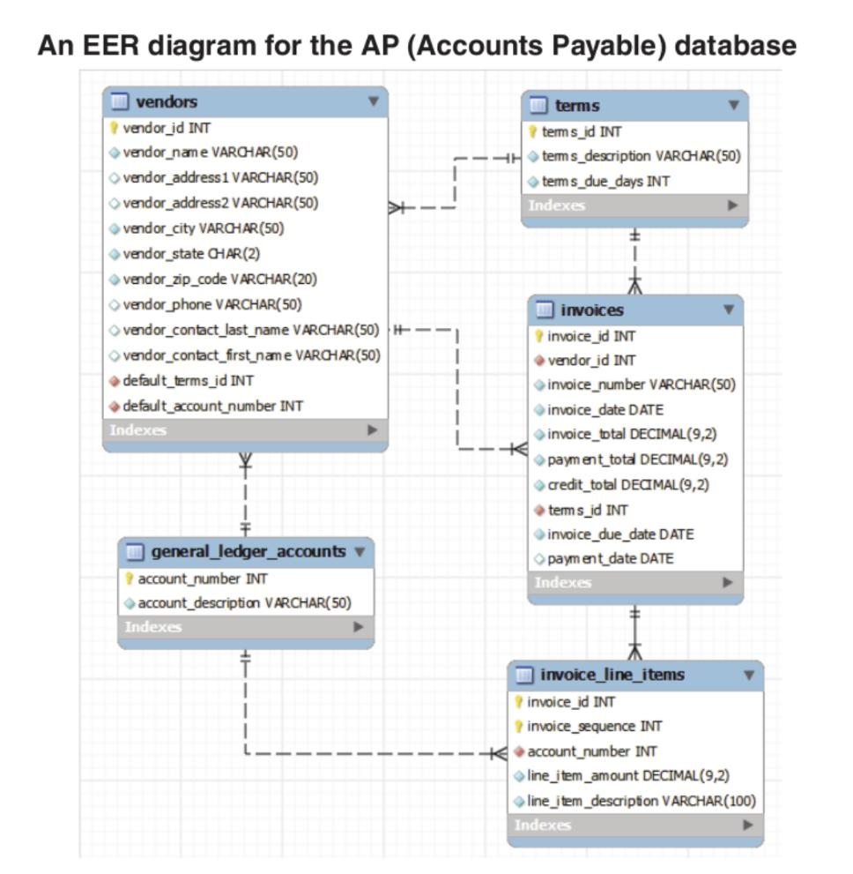

What foreign key for the general_ledger_accounts table and the terms table relate to a primary key in the other tables?

* **Terms** table and **vendors** table: So the foreign key *default_terms_id* relates the vendors table to the primary key *term s_id* in the terms table.
* **Terms** table and **invoices** table: The foreign key term s_id relates the invoices table to the primary key term s_id in the terms table.
* **Terms** table and **general_ledger_accounts** table:
* **Terms** table and **invoice_line_items** table:
* **General_ledger_accounts** table and **vendors** table: The foreign key default_account_number relates the vendors table to the primary key account_number in the general_ledger_accounts table.
* **General_ledger_accounts** table and **terms** table:
* **General_ledger_accounts** table and **invoices** table: The foreign key line_item_amount
* **General_ledger_accounts** table and **invoice_line_items** table:

1. How is the general_ledger_accounts table related to the vendors table? You must name the column that relates.
2. How is the terms table related to the invoices table? You must name the column that relates.